A000-Asia-Parthia-Light Horse Cavalryman and Rider-300 BCE

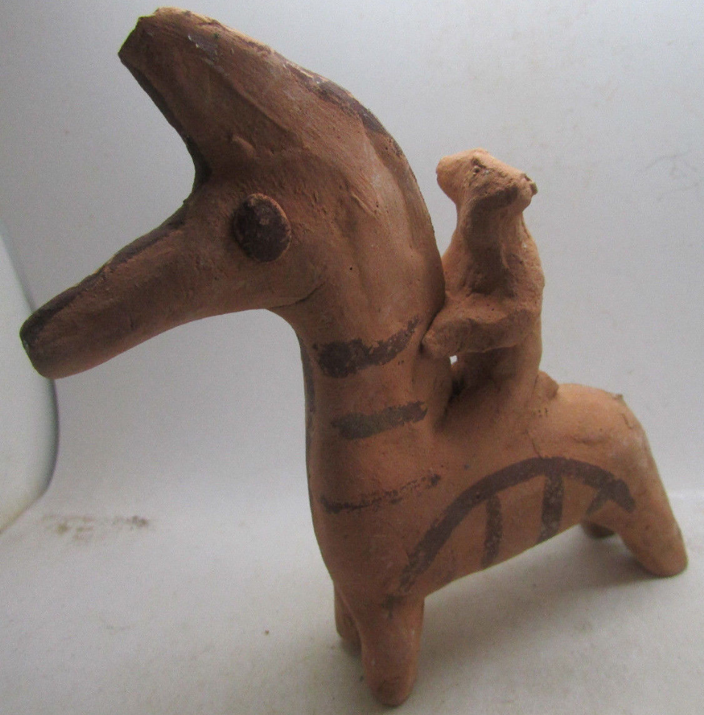

**Case no.: 4**

**Accession Number:**

**Formal Label:** Asia-Parthia-Horse and Rider-1000 BCE

**Display Description:**

Parthia in north-eastern [Iran](https://en.wikipedia.org/wiki/Iran) was invaded by Scythian exiles in the 10th -9th centuries who were called Parthi" (Smith n.d.).” In the 7th c they were conquered by the [Medes](https://en.wikipedia.org/wiki/Medes) and later incorporated into the [Achaemenid Empire](https://en.wikipedia.org/wiki/Achaemenid_Empire) under [Cyrus the Great](https://en.wikipedia.org/wiki/Cyrus_the_Great) in the 6th century BCE. After the [4th-century-BCE conquests](https://en.wikipedia.org/wiki/Wars_of_Alexander_the_Great) of [Alexander the Great](https://en.wikipedia.org/wiki/Alexander_the_Great) they formed part of the [Hellenistic](https://en.wikipedia.org/wiki/Hellenistic) [Seleucid Empire](https://en.wikipedia.org/wiki/Seleucid_Empire). By the 3rd c BCE the [Eastern-Iranian](https://en.wikipedia.org/wiki/Eastern_Iranian_languages) [Parni](https://en.wikipedia.org/wiki/Parni) people and Arsacid dynasty, rulers of the [Parthian Empire](https://en.wikipedia.org/wiki/Parthian_Empire) (247 BC – 224 CE) overtook them. Finally, in the 2nd c the seven Parthian clans were controlled as a feudal aristocracy under the last [pre-Islamic Persia](https://en.wikipedia.org/wiki/Pre-Islamic_Persia)n state, the [Sasanian Empire](https://en.wikipedia.org/wiki/Sasanian_Empire).

**LC Classification:**

**Date or Time Horizon:**

**Geographical Area:**

**Map:**



The region of Parthia within the empire of [Medes](https://en.wikipedia.org/wiki/Medes), c. 600 BC; from  Shepherd 1926. **GPS coordinates: 60E, 35 N**

**Cultural Affiliation:** Parthia

**Media:** terracotta, black slip.

**Dimensions:**

**Weight:**

**Condition: original**

**Provenance:**

**Discussion:**

When [Arsaces I](http://www.parthia.com/arsaces1.htm) overthrew the Seleucid governor of Parthia and made himself king in 247 B.C., he set into motion a number of events that would literally change the world, providing he could keep Antiochus III from reclaiming his lost territories, territories conquered in the days of Alexander the Great. The Seleucids as a whole were not a pleasant people and antagonized many of their conquered subjects in the few hundred years that they ruled the Middle East. More interested in breeding war elephants than horses, they influenced the likes of Pyrrhus of Macedonia and Hannibal, who both overestimated the effectiveness of battle elephants in Europe.

Alexander the Great's cavalry was the decisive factor in many of his battles against the Persians and their allies. And the Scythians, the great horsemen of the Steppes, were responsible for more than their fair share of Persian casualties. Mounted archers on swift horses originally stolen from the Medes, the Scythians and their related tribes were responsible for the deaths and defeats of Cyrus the Great, the founder of the Persian Empire, and King Darius, who learned the hard way what a frog, arrow and bird represented to King Idymanthrus of Scythia.

[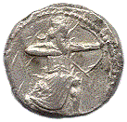](http://www.parthia.com/coins/pdc_1128.jpg)

[Single curve bow on silver tetradrachm of Artaxerxes III Ochus, ca. 333 B.C., 21.7 mm, 15.1 gm. Photo by permission [Calgary Coin Gallery](http://www.calgarycoin.com/)]

|  |  |
| --- | --- |
| **Parthian Light Horse Cavalryman** | **Parthian Heavy Horse Cavalryman** |
| [Click image to enlarge](http://www.parthia.com/images/lighthorse.gif) | [Click image to enlarge](http://www.parthia.com/images/heavyhorse.gif) |
| [Graffiti from private houses, Dura Europos. Earlier third century A.D. (After M. Rostovzeff, *Caravan Cities*, figs. 2-3)] | |

The Parthians also adopted the Scythian bow, a double curve weapon ideal for horseback. The original Persian bow was a single curved weapon that was used by footmen. The Persians themselves seemed to prefer using spears when mounted since it did not require as much skill to kill a lion.

One thing the Parthians did not adopt from the Scythians was their horse. The Scythians used several breeds of horse with the golden Akhal-Teke being their preferred mount. Their obsession with golden colored horses resulted in a large number of golden chestnuts and golden bays being found among the tribes and in the Scythian ice tombs. The Russian Don, now inhabiting the region once ruled by the Scythians, comes predominantly in golden chestnut and bay.

[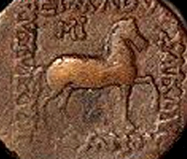](http://www.parthia.com/coins/pdc_3634.jpg)

[Bronze tetrachalkous of Mithradates II (c. 123 - 88 B.C.), 21 mm, 6.6 gm. Photo by permission Doug Smith's [Ancient Greek & Roman Coins](http://mywebpages.comcast.net/dougsmit/)]

---------------------------------------------------------------------------------------------------------------------

**References:**

Altimira, Rafael (trans. By Muna Lee). *A History of Spain* (Toronto: D. Van Co., 1949)

Arribas, Antonio. *The Iberians*. (New York: Frederick A. Praeger, 1963)

Ashberry, A. J. *The Legacy Of Persia*. (Oxford: Oxford University Press, 1953/1963)

Browning, Robert. *Justinian and Theodora* (New York: Frederick A. Praeger, 1971)

Culican, William. *The Medes and Persians*. (New York: Frederick A. Praeger, 1965)

Forte, Nancy. *The Warrior in Art*. (Minneapolis, MN: Lerner Pub., 1966)

Haussig, H. W. (trans. by J. W. Hussey).*A History Of The Byzantine Civilization*. (New York: Frederick A. Praeger, 1966/1971)

Hopkins, Edward C. D. [The Parthian Empire](http://www.parthia.com/) (web site)

McNulty, Henry. "The Horses of Jerez", *Gourmet*, June 1983

Ogata, Osamu. The Origins of "Yabusame" (Horseback Archery), 10 Jan 95 (web page)

Payne, Robert. "The Parthians" in *The Splendor of Persia*. (New York: Alfred A. Knopf, 1957)

Rice, Tamara Talbot. *The Scythians*. (New York: Frederick A. Praeger, 1957)

Roux, Georges. *Ancient Iraq*. (New York: The World Pub. Co., 1964)

Shepherd, William Robert.1926. Historical Atlas, 5th ed. New York: Henry Holt.

(Smith, Andrew. N.d. "Justinus: Epitome of Pompeius Trogus (7)". *http://www.attalus.org/translate/justin7.html#41.1* )

Varley, Victoria. President, [The Tiger Horse Registry](http://www.tigrehorse.com/) (web site)

Wild, Oliver. [The Silk Road](http://www.ess.uci.edu/~oliver/silk3.html) (web page)

[Yabusame](http://www.japanpage.org/photo/yabusame.htm), or Japanese horseback archery (web page)

Zuelke, Ruth. *The Horse In Art*. (Minneapolis, MN: Lerner Pub., 1965)